**LAB 1c: GETTING STARTED WITH PYTHON**

**Part A:** Learn how to use print and input in Python

1. Write a program to get an input word from a user. Then, display the given word together with the sentence of “Welcome, ” as below:

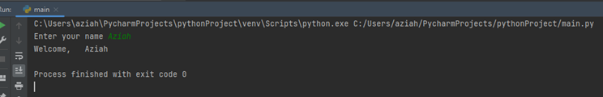

1. Write a program to get two inputs from user. Then display the input.

**Output sample:**

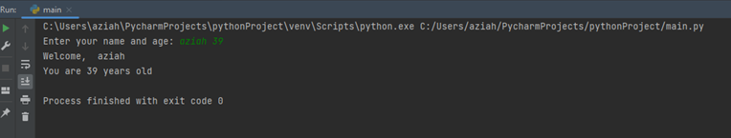

**Part B:** Learn how to use the Selection control statements (if, if..else, if..elif..else) in Python

1. Write a program to check if the given number is even or odd.

**Output sample:**

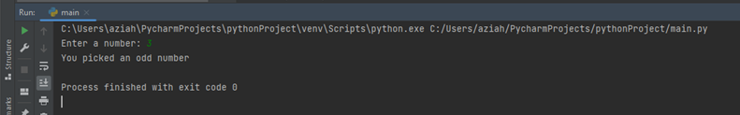

1. Write a program to find the largest numbers between 2 numbers.

**Output sample:**

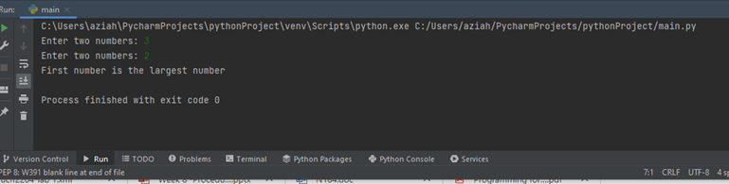

Enter different value for the input as follow:

10, 20

5, 5

25, 15

Print the output for the difference values.

**Part C:** Test yourself!

1. Lecturers often provide scores on tests, which are converted to grades the end of the semester. Write a python program to ask for the score input and print the respective grade as follow:

|  |  |
| --- | --- |
| Score | Grade |
| Above 80 | A |
| 60 - 79 | B |
| 40 - 59 | C |
| Below 40 | D |
|  |  |

1. **Restaurant Selector**

You have a group of friends coming to visit for your university reunion, and you want to take them out to eat at a local restaurant. You aren’t sure if any of them have dietary restrictions, but your restaurant choices are as follows:

|  |  |  |  |
| --- | --- | --- | --- |
| Restaurant | Vegetarian | Vegan | Gluten-Free |
| Joe’s Gourmet Burgers | No | No | No |
| Main Street Pizza Company | Yes | No | Yes |
| Corner Café | Yes | Yes | Yes |
| Mama’s Fine Italian | Yes | No | No |
| The Chef’s Kitchen | Yes | Yes | Yes |

Write a program that asks whether any members are vegetarian, vegan, or gluten-free, to which then displays only restaurants to which you may take the group. Here is an example of the program’s output:

